Mesh Shaders in DirectX 12

Contents
Overview 2
Rasterization 2
A brief look at the traditional rendering pipeline 2
Meshlets 3
Generating Meshlets 3
D3D12 API 3
Mesh Shaders D3D12 API 4
Building the root signature 4
Building the pipeline 5
Dispatch Mesh 6
Mesh Shaders HLSL 6
Input and Output Arguments 6
Custom Rendering Data Structures 7
Amplification Shaders 8
Overview 8
Examples 8
Limitations 9
Best Practices 9
Resources 10

Overview

Mesh shaders and amplification shaders (MS and AS) are a new generation of graphics pipeline introduced in DirectX 12. The primary aim of mesh shaders is to simplify the existing rendering pipeline while offering the programmer the immense power of asynchronous programming. With the new geometry pipeline, it is now possible to implement features such as mesh culling, particle systems and dynamic level of detail systems directly into the rendering pipeline.

Rasterization

A brief look at the traditional rendering pipeline

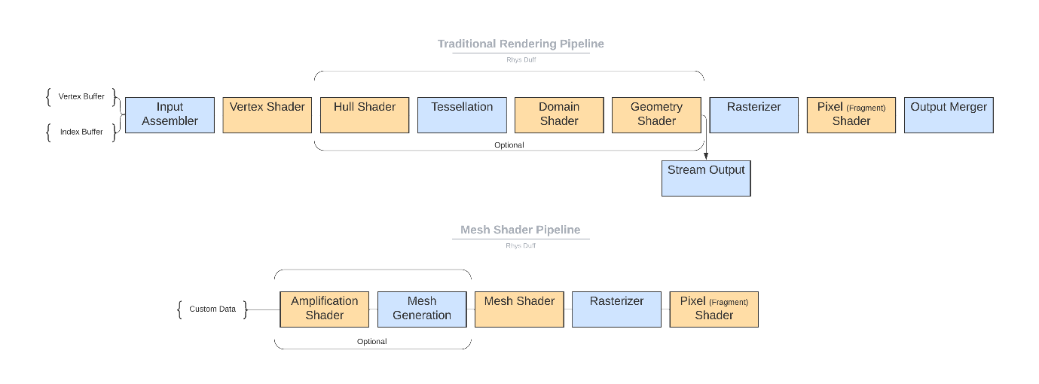
Figure 1 – Two diagrams illustrating the traditional rendering pipeline (top) and the new mesh geometry pipeline (bottom)
The main motivation for using mesh shaders is to improve both the performance and flexibility of the geometry pipeline. While the traditional pipeline has evolved to become immensely powerful, for instance vertex shaders are an effective programming model enabling massive hardware parallelization, the traditional pipeline has not evolved to match modern compute programming techniques. Another issue is the linearity of the pipeline. Each thread operates on one aspect of the geometry, vertex shader operates on a vertex, hull shader operates on a control point, the domain shader operates on a tessellated vertex and the geometry shader operates on a primitive.
The traditional pipeline also suffers from inflexible data layouts. Input data is limited to either a vertex buffer or a vertex buffer and index buffer.
Mesh shaders can be roughly described as subsuming the vertex and geometry shader or the domain and geometry shader. Similarly, the tessellation stages are now replaced with the combined use of the amplification shader and mesh shader. You can learn even more about why we should use mesh shaders with the following video linked here. In essence, mesh shaders are compute shaders which submit triangle lists to the rasterizer.

Meshlets

A meshlet is a small collection or group of primitives which comprise the entire 3D model. The screenshot below illustrates how meshlets can be visualised using the PrimitiveId to calculate group colours in the pixel shader.

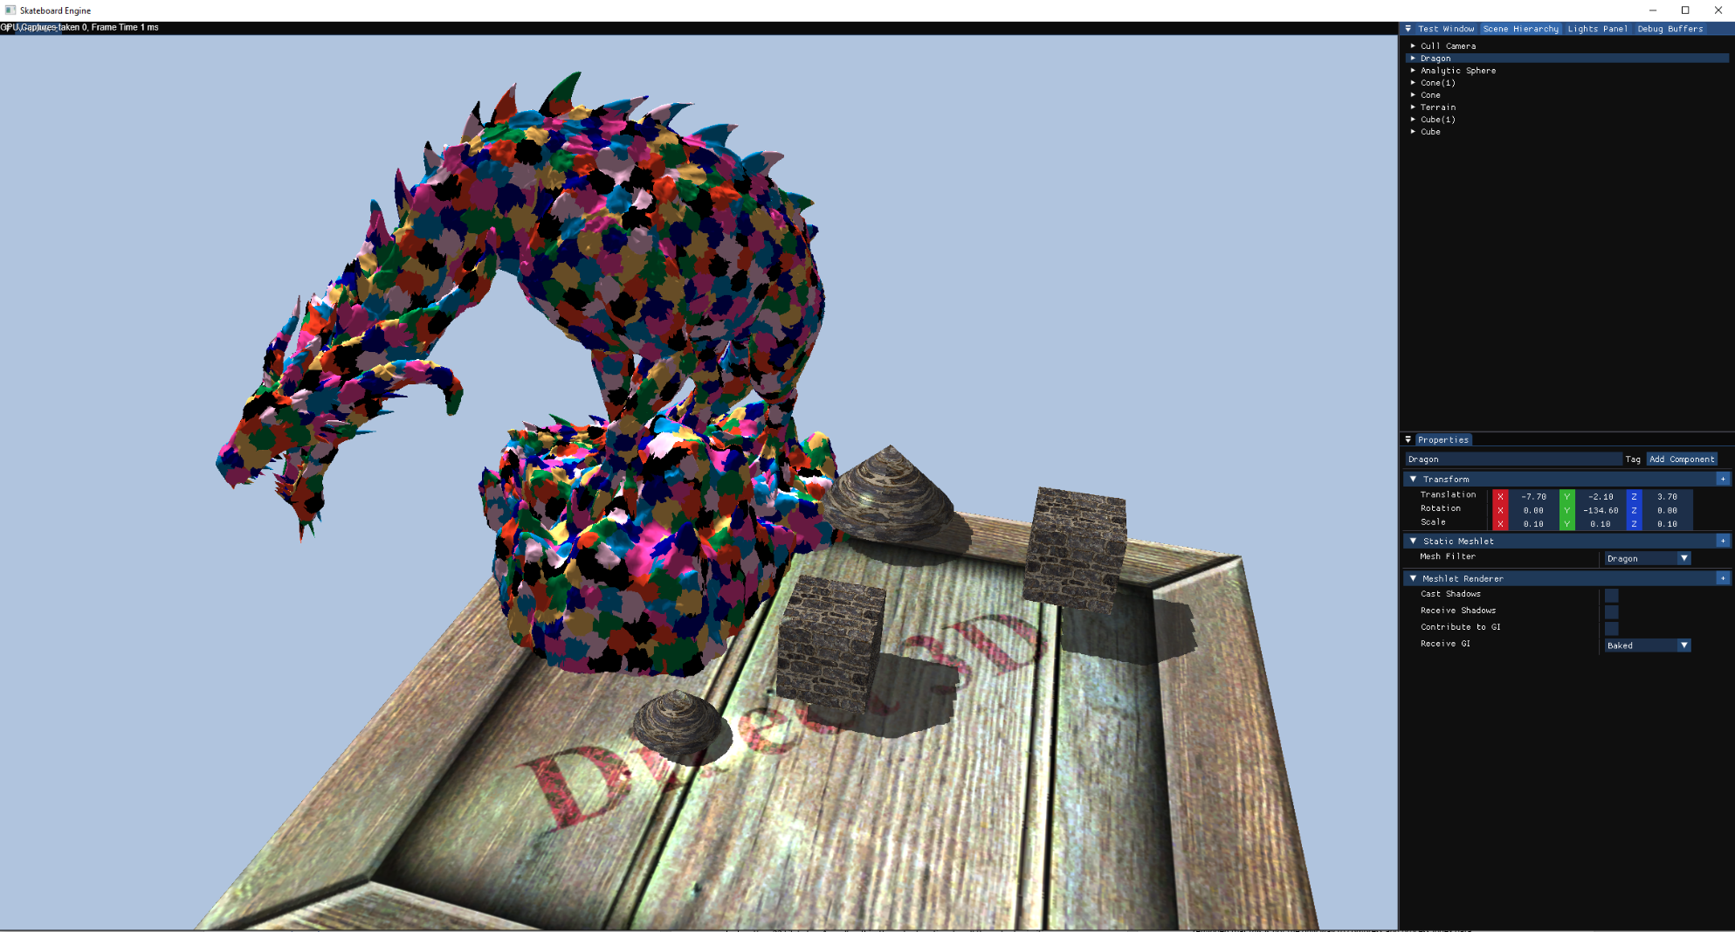

This is useful for advance rendering techniques such as meshlet culling, where meshlets which fall out with the camera frustrum are discarded. It is important to note despite there being API in DirectX which can convert mesh into meshlets, and that this document focuses on this data structure, you can send any data structure you deem appropriate. To reiterate, mesh shaders are essentially compute shaders. If you are familiar with compute shaders then you’ll begin to understand the sorts of possibilities which await. And if you don’t, this is fine too!

Generating Meshlets

D3D12 API

Microsoft have provided open-source code to generate meshlets from traditional vertex and index buffers under the "D3D12MeshletGenerator.h" header file. The file additionally includes functions for calculating culling data for mesh and models. The files are included as part of the D3D12WavefrontConverter project in the Mesh Shader sample projects. The download can be found here.

Mesh Shaders D3D12 API

Building the root signature

Just like building root signatures for the traditional rasterization pipeline, the mesh shader root signature can receive references to the types of resources which are expected to be bound to the pipeline at runtime. The root signature can be populated on the CPU by using the D3D API, in addition to pulling the root signature defined in HLSL.
Note, the latter method of building a root signature is supported from shader model version 5.1+. Defining the root signature in HLSL is achieved by creating a #define somewhere within the shader file and before the entry point to your shader. An example is shown below:

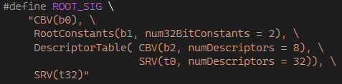

Declaring root signature flags is accomplished by specifying RootFlags(0) within the string. The root flags example stipulated above reflects the default flag, in which no specified flags were stated. Specifying flags is inserted between the parenthesis, and multiple flags can be concatenated using the bitwise OR operator. For more root arguments in HLSL, you can visit the following documentation linked here.

To attach the root signature to the shader, you can use the following API:
Failure to attach the root signature using the API above results in a D3D12 error whilst attempting to create the root signature. To compile the root signature when you have defined the root signature in HLSL, use the CreateRootSignature() API. The function takes four arguments, the node mask, a pointer to the shader buffer containing the root signature, the shader size in bytes and a pointer to the root signature interface.
It is also possible to manipulate the root signature using the FXC compiler as well as programmatically through the D3D API. Note you will need to include the following header file, <d3dcompiler.h> , to access the following functions. D3DCompile() compiles a root signature from a blob. D3DGetBlobPart() and D3DSetBlobPart() can retrieve root signatures from blobs and attach root signatures to blobs respectively with the corresponding flag D3D_BLOB_ROOT_SIGNATURE .
D3DStripShader() removes the root signature from the shader using the flag D3DCOMPILER_STRIP_ROOT_SIGNATURE.

Mesh Pipeline

It is assumed you are familiar with rendering pipelines in DirectX 12 and how to construct traditional rendering pipelines. If you do not, here is a very simple overview of rendering pipelines in DirectX 12.

Overview

In DirectX 12, rendering pipelines are what hold all the instructions which are to be executed on the GPU. You can think of rendering pipelines to completely describe geometry appearance on screen. You provide descriptions to a pipeline, should the object be back-faced culled? Is the winding order clockwise or counterclockwise? Additionally, you attach shaders to the pipeline object. You can bind any shader as illustrated in figure 1 from the Traditional Rendering Pipeline diagram.

Building the pipeline

Before building the pipeline state, it is important to query your system to check if mesh shaders are supported with the current feature level. Mesh shaders are only available on DirectX 12 ultimate, Vulkan, OpenGL and PlayStation 5. You can check that your device supports mesh shaders using the D3D12_FEATURE_DATA_D3D12_OPTIONS7 API. Below is a complete snippet of code to query compatibility:
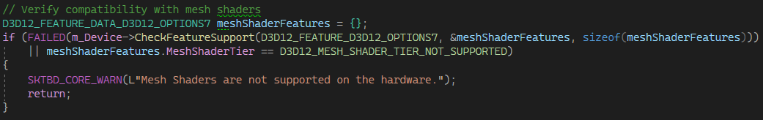
Like the traditional rendering pipeline, to use mesh shaders a pipeline state is required in addition to a root signature. The mesh shader pipeline can be described using the special D3D12 struct D3DX12_MESH_SHADER_PIPELINE_STATE_DESC. If you do not have immediate access to this struct, make sure you have included <d3dx12.h> at the top of your .cpp.
The pipeline expects shader byte code, in addition to supporting pipeline descriptions such as the blend state, raster state and depth state. There are a few points to highlight whilst filling out the pipeline descriptions. The pipeline does not expect any other attached shader stages other than the optional amplification shader, mesh shader and pixel shader. Additionally, you are not required to attach a pixel shader if you do not desire to rasterize the object. This is common if you seek to perform UAV accesses using a mesh shader.
The mesh shader pipeline does not support the input assembler or stream out. It is possible, as previously mentioned, to conduct unordered access writes thereby allowing for data to be copied back to the CPU. As there is no support for the input assembler, you are not required to set a vertex buffer nor an index buffer. Instead, the input data is entirely up to the developer. More on custom data structures for rendering mesh in the sections below.

Dispatch Mesh

The DispatchMesh() API adds an instruction to command list which will invoke the mesh shader, or if one is attached, the amplification shader once the ExecuteCommandLists() is called. DispatchMesh() takes three arguments, ThreadGroupCountX, ThreadGroupCountY and ThreadGroupCountZ . Like the compute shader, these arguments represent the number of thread groups to dispatch along each axis. It is important to note, the maximum number of thread groups you can dispatch along an axis with a mesh shader, or amplification shader, is 65536 thread groups.
Furthermore, it is important to remember, calling dispatch mesh will not invoke the mesh shader until the execute command lists API is invoked.

Mesh Shaders HLSL

Input and Output Arguments

It will become apparent that mesh shaders share several common features to compute shaders. Like compute shaders, mesh shaders can take several different arguments as input. These include the following:
- SV_GroupThreadID
- SV_GroupID
- SV_DispatchThreadID
- SV_View
Additionally, there are new arguments marked for output and input. These are:
- out indices
- out vertices
- out primitives
- in payload

The output arrays represent the geometry which will feed into the pixel shader. The size of these arrays represents the worst case expected output. At runtime, use the API, SetMeshOutputCounts() to set the final vertex and primitive count expected to be exported from the current thread group. You need to call this function and set the parameters accordingly before processing and exporting geometry. Internally, the counts are set to 0. Hence not calling this function will result in no mesh being rendered.
It is important to acknowledge the output size limitations. The output vertex data size must be less than 32 kilobytes. As well as this, the output vertices for all the output primitives must be written in the mesh shader otherwise behaviour is undefined. You can read more about mesh shader limitations here.
The input argument payload represents a custom block of data passed into the mesh shader from the optional amplification shader.

Custom Rendering Data Structures

As already discussed, the next generation of geometry pipeline is highly flexible, hence it is entirely up to the developer how they manage and sort rendering data. For learning purposes however, a study into the Microsoft mesh shader sample projects can assist our understanding of just one of the many ways to layout mesh data.
One aspect of the structure that hasn’t changed is the vertex buffer. However, rather than binding the vertex buffer using the IASetVertexBuffers() API, you are expected to bind the buffer as a shader resource view, or unordered access view.
In HLSL, the vertex buffer can be defined as a structured buffer, with a typing matching the vertex data layout.
It becomes apparent, that the index buffer is now replaced by three new buffers. These are:

- Meshlet Buffer
- Primitive Index Buffer
- Unique Vertex Index Buffer

First, the meshlet buffer. This buffer contains a few pieces of data which will prove useful in extrapolating the vertex associated with the current SV_GroupThreadID as well as the current primitive associated with the SV_GroupID.
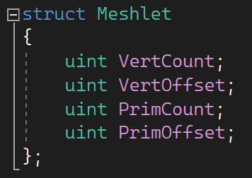
The VertCount variable tells us how many vertices to expect for the current primitive just as they PrimCount variable, informs us on the number of primitives associated with the current meshlet.
VertOffset represents the offset into the vertex buffer. To extrapolate the vertex associated with the current thread, we can use the offset in addition to our SV_GroupThreadID to index into the vertex buffer. The next step will seem familiar, once we have extrapolated the vertex, we can project the 3D world space coordinates into homogenous coordinates.
Further, we can construct the necessary indices for the current primitive using both the PrimOffset and our SV_GroupThreadID to fetch into the primitive index buffer. In the examples, the primitive indices have been packed into a 32-bit integer. Specifically, observe the precision of each index has been truncated to 2 to the 10-bits, and bit shifted into the unsigned integer accordingly. This is a common compression technique, and it should be reminded that this is not the only way to compress and process index data.
Both the vertex and primitive data can be inserted into the output vertex and primitive arrays respectively using the SV_GroupThreadID.

Amplification Shaders

Overview

There is no API specific to amplification shaders. Instead, if an amplification shader is bound to the pipeline state, invoking the DispatchMesh() API will add an instruction to the command list and invoke the amplification shader upon executing the rendering queue.
The main purpose of the amplification shader is to dispatch mesh shader thread groups on the system. Something to be mindful about, if you intend on dispatching an amplification shader, ensure one is bound to the pipeline description. Invoking DispatchMesh() will add an instruction to the command list to dispatch the attached amplification shader. Then, from the amplification shader, you can dispatch mesh shaders with a similar HLSL call DispatchMesh().
The first three arguments for DispatchMesh() represent the thread group count, just as with the D3D12 API equivalent. There is a fourth optional argument which represents the payload. The payload is a custom struct of data which can be fed into the mesh shader.
Note that the payload must not exceed 16 kilobytes in size. The data within the payload can be anything the developer desires. Often, the data which is computed in the amplification shader is intended for use in the mesh shader.

Examples

With the addition of the amplification shader and mesh shader pipeline, its possible to implement a wide variety of systems directly into the geometry pipeline. A popular example is dynamic meshlet culling. Rather than culling entire objects, it is now possible to cull meshlets which fall out with the bounds of the camera frustrum. This can help improve performance as well as visual quality.

Limitations

The following is a summary of the core limitations for mesh shaders:
- Number of threads in a group is limited to a maximum 128 threads.
- Group shared memory is limited to 28 kilobytes.
- Output vertices must not exceed 256.
- Output primitives must not exceed 256.
- Output vertex data size must not exceed 32 kilobytes.

Best Practices

Mesh shaders are an incredibly powerful technology empowering developers to achieve feats otherwise impossible with previous geometric pipelines. It is also sensible to cover some of the best practices when it comes to implementing new rendering pipelines and workflows. Current limitations have been stipulated in the previous section and it is a good idea to go into further detail regarding a couple of things.
Number of threads in a group – on NVIDIA GPUs, SIMD cores are composed of 32 threads on a warp. It is a good practice to select a multiple of 32 (not exceeding 128) to ensure the GPU has adequate work submission. It is also worth pointing out, work efficiency is also strongly connected to the code you write in a mesh shader. For instance, avoid branching if possible and ensure all your threads have enough work for the duration of the mesh shader.
Generating meshlets – it is advised not to generate meshlets at load times as this can be a heavily taxing task, especially on dense models. A better approach would be to generate the necessary buffers at load times once during development and serialise the data to disc. This way, the data can be parsed on shipped applications avoiding unnecessary bottlenecks from generating buffers from scratch.
Handling legacy hardware – mesh shaders are not supported on all graphics card vendors. When it comes to designing your rendering engine, it is important to account for backwards compatibility if you decide to support mesh shaders. As discussed already, the input data is entirely up to you. Generating meshlets can be demanding task therefore it is best to generate Index Buffers at load times in the event mesh shaders are not supported and not the other way around.

Resources

A half-hour presentation covering the motivation for mesh shaders and the future for the geometry pipeline: https://youtu.be/CFXKTXtil34?t=1
You can find sample projects covering everything from the basics of mesh shaders to advance techniques such as dynamic LODs and meshlet culling: https://learn.microsoft.com/en-us/samples/microsoft/directx-graphics-samples/d3d12-mesh-shader-samples-win32/
For detailed information on the new geometry pipeline covering how to fill out pipeline descriptions as well as current limitations, then the DirectX-Specs is: https://microsoft.github.io/DirectX-Specs/d3d/MeshShader.html

